**Use Colab to run the code:**

**Upload your notebook to Colab, Method 1:**

1. Go to colab.research.google.com
2. Choose upload from right panel

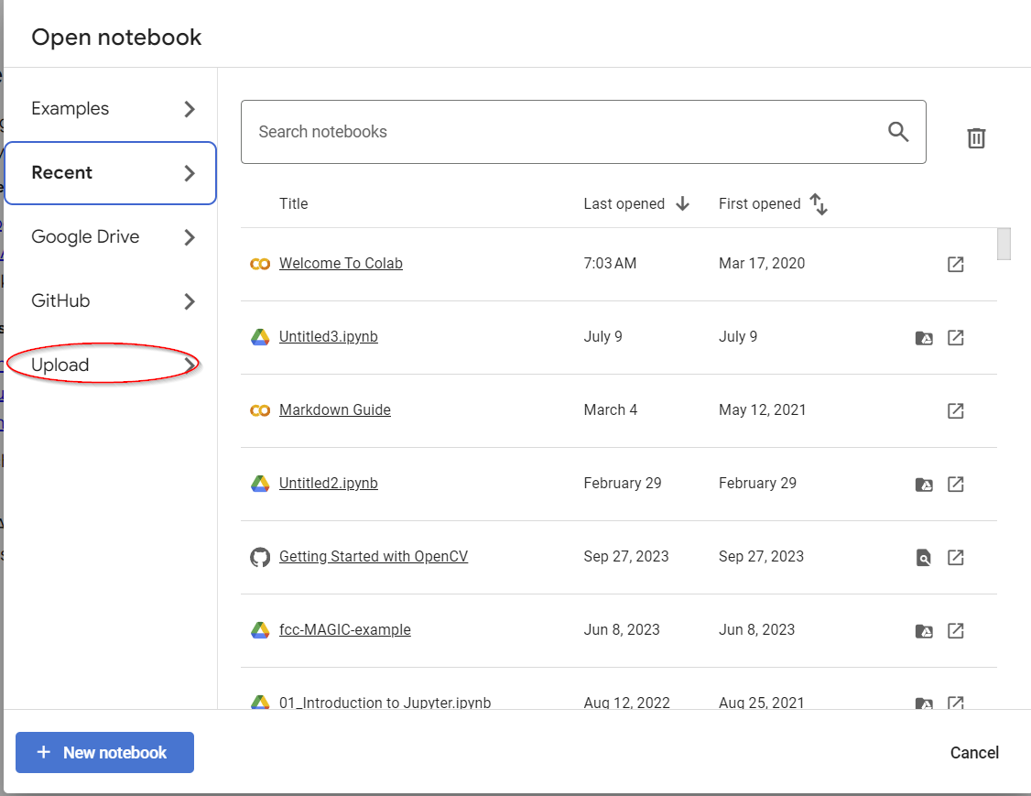

1. Browse and upload the local file. You can also directly upload from Github

**Upload your notebook to Colab, Method 2** (You can upload multiple files at a time)**:**

1. Go to drive.google.com. Select "My Drive" from the left.

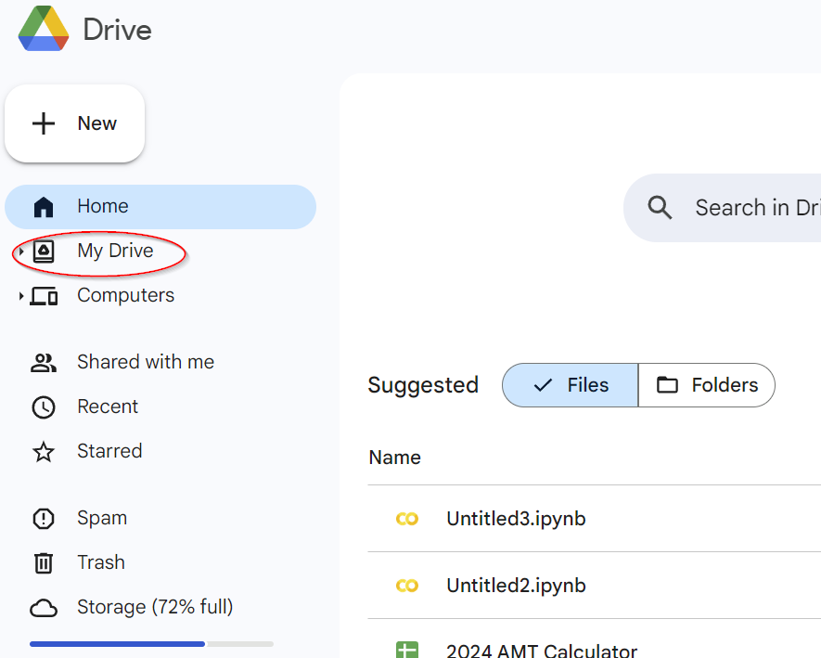

1. Find a folder named: "Colab Notebooks". Click it to enter this folder.
2. Drag and drop notebook files to this folder.
3. Click the notebook you intend to open.

**Upload data files to Colab:**

1. Open the notebook.
2. On the left panel, click the folder icon



1. Click upload icon

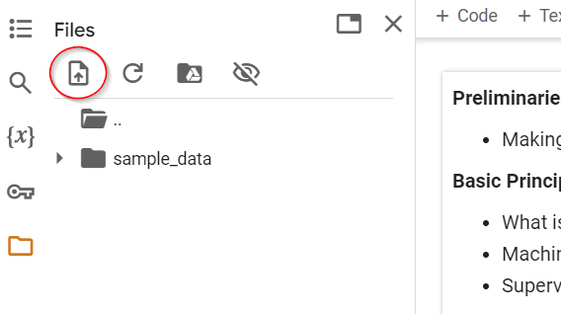

1. You may need to create folders (by right-clicking to open a menu) to keep the structure of folders/files.
2. Note that these files are just for this session. When you close the session, you have to upload those files again.